AIR CONDITIONER

WITH

REMOTE CONTROL

*Minor project of*

*Course Title: Skilling (LabVIEW)*

*Course code: 17TS401*

*Submitted by*

*I. GOVINDA RAO(170040295)*

*J. PAVAN SAI (170040307)*

*J.V.N.D.S.R.Prasad (170040320)*

*Submitted to*

*Ms. Mona Mudaliar*

*(Asst. professor)*Department of ECE



**BONAFIDE CERTIFICATE**

This is to certify that the projectbased laboratory report entitled “Air conditioner with remote control**”** submitted by I Govinda rao, J Pavan sai, J. Prasad, bearing registration numbers 170040295, 170040307, 170040320, in partial fulfillment of project based lab in skilling for II/IV **Bachelor of Technology in Electronics and Communication Engineering** is a bonafide record of the work carried out under our guidance and supervision at KL University during the academic year 2018-19

**Signature of HOD Signature of Project Guide**

**ACKNOWLEDGEMENT**

It is great pleasure for me to express my gratitude to our honorable President

Sri. KoneruSatyanarayana, for giving us the opportunity and platform with

facilities for accomplishing the project based laboratory report.

We express our sincere gratitude to our Coordinator, Mr. Khanal Madhav

Prasad for his leadership and constant motivation provided for the successful

completion of our academic semester. We record it as our privilege to deeply

thank, for providing us the efficient faculty and facilities to make our ideas into

reality.

We express our sincere thanks to our project supervisor Ms. Mona Mudaliar

for her novel association of ideas, encouragement, appreciation and intellectual

zeal which motivated us to venture this project successfully.

Finally, we are pleased to acknowledge the indebtedness to all those who

devoted themselves directly or indirectly to make this project report a success.

I.D NUMBER NAME

170040295 I Govinda rao

170040307 J Pavan sai

170040320 J.V.D.S.R.Prasad

**Abstract**

An air conditioner is able to cool a building because it removes heat from the indoor air and transfers it outdoors. A chemical refrigerant in the system absorbs the unwanted heat and pumps it through a system of piping to the outside coil. The fan, located in the outside unit, blows outside air over the hot coil, transferring heat from the refrigerant to the outdoor air. Energy requirement for refrigeration and air conditioning applications bears a huge share of total energy consumption around the world. Since, thermal comfort plays a very important role on the health, working efficiency and activities of all living beings, especially, temperature and humidity. In the excessively hot climates it is necessary to reduce the temperature and humidity whereas in the cold climate there is a need to increase the temperature. When the temperature drops below thermal comfort level, especially in the winter season, the heating systems are employed. In some countries, where the atmospheric temperature is very low, natural heating like solar energy is not sufficient, the heat pump and fuel fired systems are proven to be suitable heating devices. In hot climates, thermal comfort achieved through the use of air conditioner monitoring systems.

Table of Contents

|  |  |  |
| --- | --- | --- |
| S.no | Name of contents | Page no |
| 1 | Introduction | 7 |
| 2 | Methodology | 8 |
| 3 | Technical Description of Project | 9 |
| 4 | Experiments and Result | 10 |
| 5 | Conclusion and Future Scope | 11-14 |

List of Figures

1.Air Conditioner

2.Remote Control

3.Automatic AC Control Panel

1. Introduction

## 1.1 **Basic Operations**

An air conditioner is able to cool a building because it removes heat from the indoor air and transfers it outdoors. A chemical refrigerant in the system absorbs the unwanted heat and pumps it through a system of piping to the outside coil. The fan, located in the outside unit, blows outside air over the hot coil, transferring heat from the refrigerant to the outdoor air.

1.1.1 Most air conditioning systems have five mechanical components:

• a compressor  
• a condensor  
• an evaporator coil  
• blower  
• a chemical refrigerant

Most central air conditioning units operate by means of a split system. That is, they consist of a ‘hot’ side, or the condensing unit—including the condensing coil, the compressor and the fan—which is situated outside your home, and a ‘cold’ side that is located inside your home.

1.2 Main functions

The compressor (which is controlled by the thermostat) is the ‘heart’ of the system. The compressor acts as the pump, causing the refrigerant to flow through the system. Its job is to draw in a low-pressure, low-temperature, refrigerant in a gaseous state and by compressing this gas, raise the pressure and temperature of the refrigerant. This high-pressure, high-temperature gas then flows to the condenser coil.

2. Methodology

2.1 Description on adapted method

2.1.1 This AC monitoring system is simply to reduce unnecessary waste of power and energy.

2.1.2 In this process, when there is room temperature is lessthan required then ac is going to off and also if temperature is greater than required then ac should be in on mode.

2.2 Description of flow of Program with flow chart

Remote Control

Air Conditioner

Control system

Display Screen

3. Technical Description of Project

This project is done using Lab View .In this project we used case structures

Boolean led designing tools on block diagram window and also by while loop for termination condition and event structures and create sub vi to implement 2 seven segment display to display temperature.

And also on front panel we created an air conditioner using tools of decorations such that we identified AC modes as by indicating led as indicator and final output . In this process, when there is room temperature is less than required then ac is going to off and also if temperature is greater than required then ac should be in on mode and it should be decrement for certain value such that ac will be in off mode.

4. Experiment and Result

With the help of lab view we have done this project “Ac monitoring system”

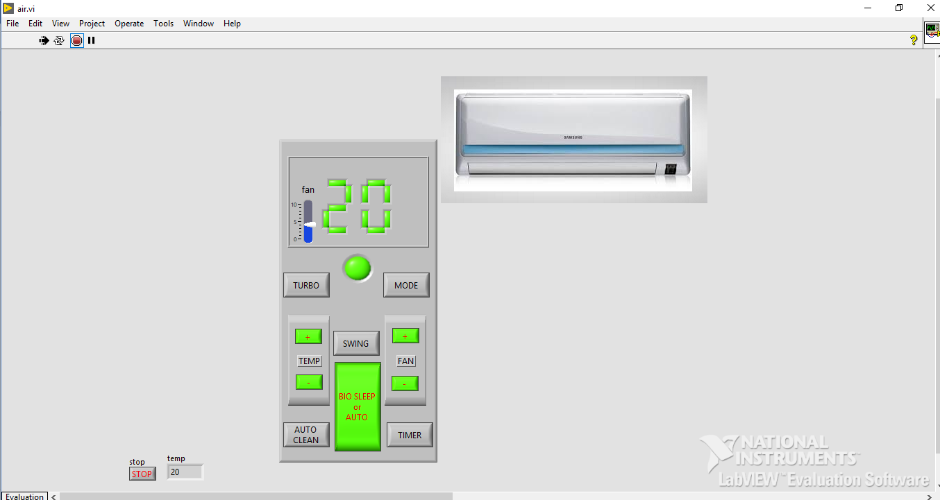Front panel:

Block diagram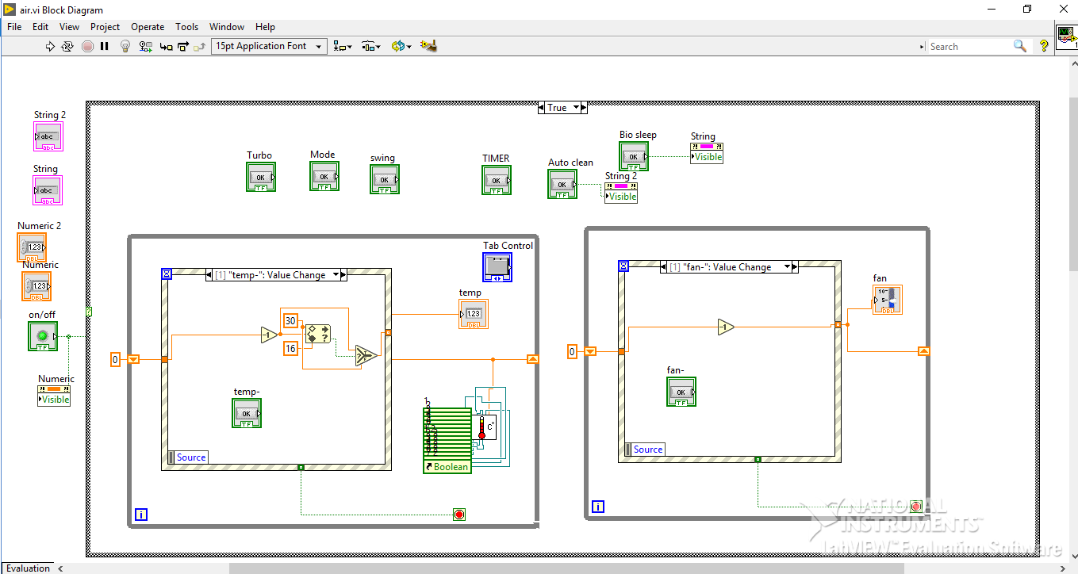:

5. Conclusion and Future Scope

## **Automatic Climate Control (Automatic A/C) in Cars:**

The Automatic Climate Control system is the most advanced of all the [air conditioning](https://carbiketech.com/car-air-conditioner/)systems in cars. It effectively controls the cabin temperature and humidity levels. In Climate Control, you can set the cabin temperature of your choice. However, the system controls it regardless of the outside air temperature and humidity. Some advanced systems offer Dual-zone climate control with automaticre-circulationmode. 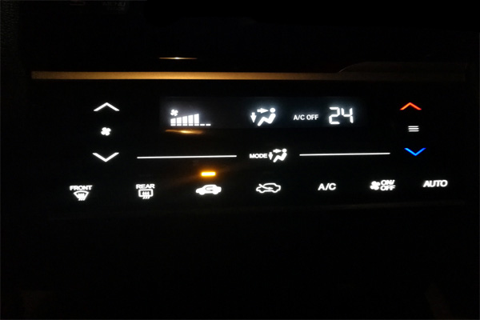

Automatic AC Control Panel

The automatic climate control system provides an individual feel-good climate for the occupants. It automatically controls the temperature, air-flow and air distribution inside the cabin. The climate control system also controls the fan speed and air circulation.

In some cases, the automatic climate control system provides electronic regulation of the air temperature, air flow rate, and air distribution. Some systems provide the

defroster nozzles for the windscreen and side windows to eliminate the fogging effect. Nowadays, budget cars also offer an Automatic [Air-Conditioner](https://carbiketech.com/car-air-conditioner/)(a step-down version of Automatic Climate Control) with touch screen panel for the ease of use.

AC air vent (Image courtesy: Bentley)

### **Features of Automatic Climate Control System:**

The automatic climate control system also measures the quality of the cabin air through various sensors. Some provide a separate climate control [ECM](https://carbiketech.com/engine-management-system-ems/) to control various sensors/actuators such as cabin air quality sensor and humidity sensor. The driver and front passenger can control the temperature separately for themselves. You can also precisely adjust the temperature levels, direction and intensity of the airflow through a touch-screen.

The Climate Control system can also maintain the temperature depending on the sunlight and the quality of the intake air through key-coded settings. Manufacturers use custom acronyms to brand their automatic climate control systems in cars. For e.g. [Mercedes-Benz](https://www.mbusa.com/mercedes/index) uses the term THERMOTRONIC for the Automatic Climate Control systems fitted in its cars.

Some manufacturers take the climate control to a new level. The driver and front passenger can independently set the temperatures of their choice for their respective areas. The rear passengers can also get better air quality with rear ventilation and re-circulation option.

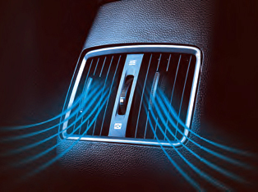Rear AC Vent (Image courtesy: Hyundai)

Mercedes-Benz provides a separate control unit with a display for the rear a/c. It also comprises of additional air outlets in the [B-pillar](https://carbiketech.com/vehicle-body-nomenclature-car-pillar/), air vents in the center console and a booster blower for the purpose. This ensures that the ideal temperature is maintained at the rear. Some manufacturers also provide 'roof a/c' or blowers in the roof in some bigger models to achieve the desired effect.

### **Automatic Climate Control in Luxury Cars:**Some ultra-luxury cars offer the state-of-the-art 4-zone air-conditioning. It includes an additional rear cabin air-conditioning unit with controls at the front and rear for fan speed and temperature. In some cars such as the [Bentley](https://www.bentleymotors.com/en/models/mulsanne/mulsanne.html) Mulsanne, you can control the rear air conditioner by the folding rear center-armrest console.Rear Climate Control in Luxury cars (Bentley)

Furthermore, some manufacturers, nowadays, provide an air-conditioned or cooled glove-box as a convenience option. So, it is getting popular among the budget car buyers. It keeps the water bottles/beverage cans cool. The cooled glove-box uses the cool air generated by the car’s air conditioner to cool the stuff put in it. So, you can keep water-bottles and the cans of aerated drinks to cool them.

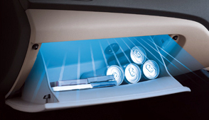Cooled Glove Box Rear AC Vent (Image courtesy: Hyundai)

### **Tips for using the Automatic Climate Control effectively:**

1. Always keep the front grill clear of any obstructions for the proper functioning of the air conditioner.
2. Always keep the windows rolled up to maximize the efficiency of the A/c.
3. Keep the air conditioner in the recirculating mode when in use
4. Use the ‘Fresh-Air’ mode only when it is necessary.
5. To improve [fuel efficiency](https://carbiketech.com/fuel-economy-car-mileage-bike-average/), use the air-conditioner only when it is necessary.